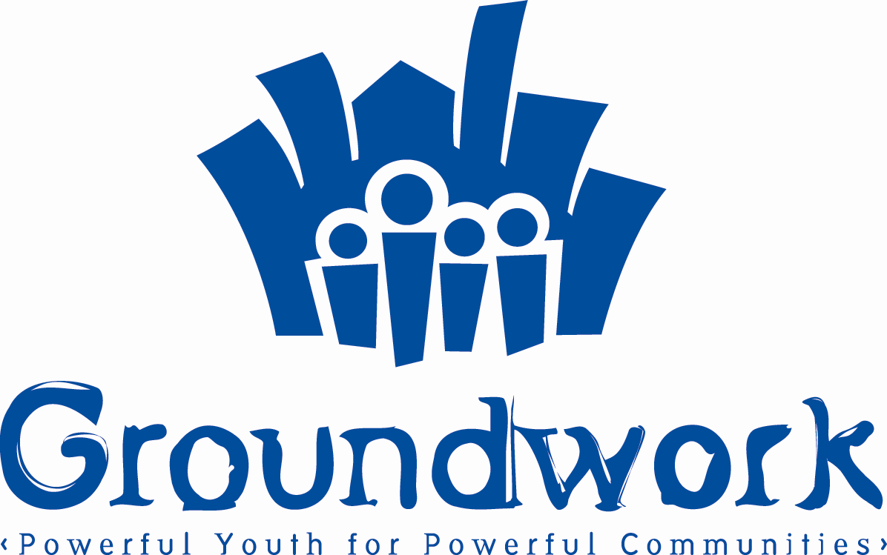

For Immediate Distribution

CONTACT
Monte Givhan
Groundwork Inc.
718 346-2200 x 108
mgivhan@groundworkinc.org

Richard Souto Leaving Groundwork, Inc. to Become Executive Director of New Heights Youth.

Brooklyn, NY (April 2, 2007). Richard Souto will be the new Executive Director of New Heights Youth in the Bronx, replacing Nick Blatchford, the Founder and current Executive Director. New Heights is an innovative program that works with student-athletes in Harlem, Washington Heights, and the Bronx, providing them with academic support, developing them as leaders, and preparing them to be successful in high school, college and life.

For Souto, a former football player at Boston University, the new position brings him back to his athletic roots. “As a student athlete, I recall feeling the pressure of very high expectations but not always having the support I needed to face those challenges” says Souto. “Student-athletes have a unique potential to be great role models in their schools and in their communities. I look forward to the challenge of supporting their development so that they can realize this extraordinary leadership potential.“

Souto has had a profound impact on Groundwork and on the East New York community. A fugitive from the private sector, Souto originally joined Groundwork as a volunteer in 2002 well before Groundwork launched its first summer academy. He soon joined the team full-time as our Associate Executive Director and a key member of the Groundwork leadership team.

Richard Buery, Groundwork’s Co-founder and Executive Director, is excited for Souto and for New Heights Youth, but will miss working alongside his friend. “Nothing we have accomplished would have been possible without him,” says Buery. “While I will personally miss working side by side with Souto every day, I am excited for him and for New Heights Youth as he takes on this new opportunity. I cannot imagine anyone more qualified.”

This sentiment is shared by Derrick Mashore, the chairman of New Heights Youth’s Board of Directors. "For New Heights, this is a moment of extraordinary possibilities. Rich Souto is a superb choice. He is the right leader and will elevate New Heights. I eagerly look forward to working with him to deliver on this promise."

Groundwork expects to name Souto’s successor within the next month.

